Given the following class definitions, which lines in the main() method generate a compiler error?

Classroom.java

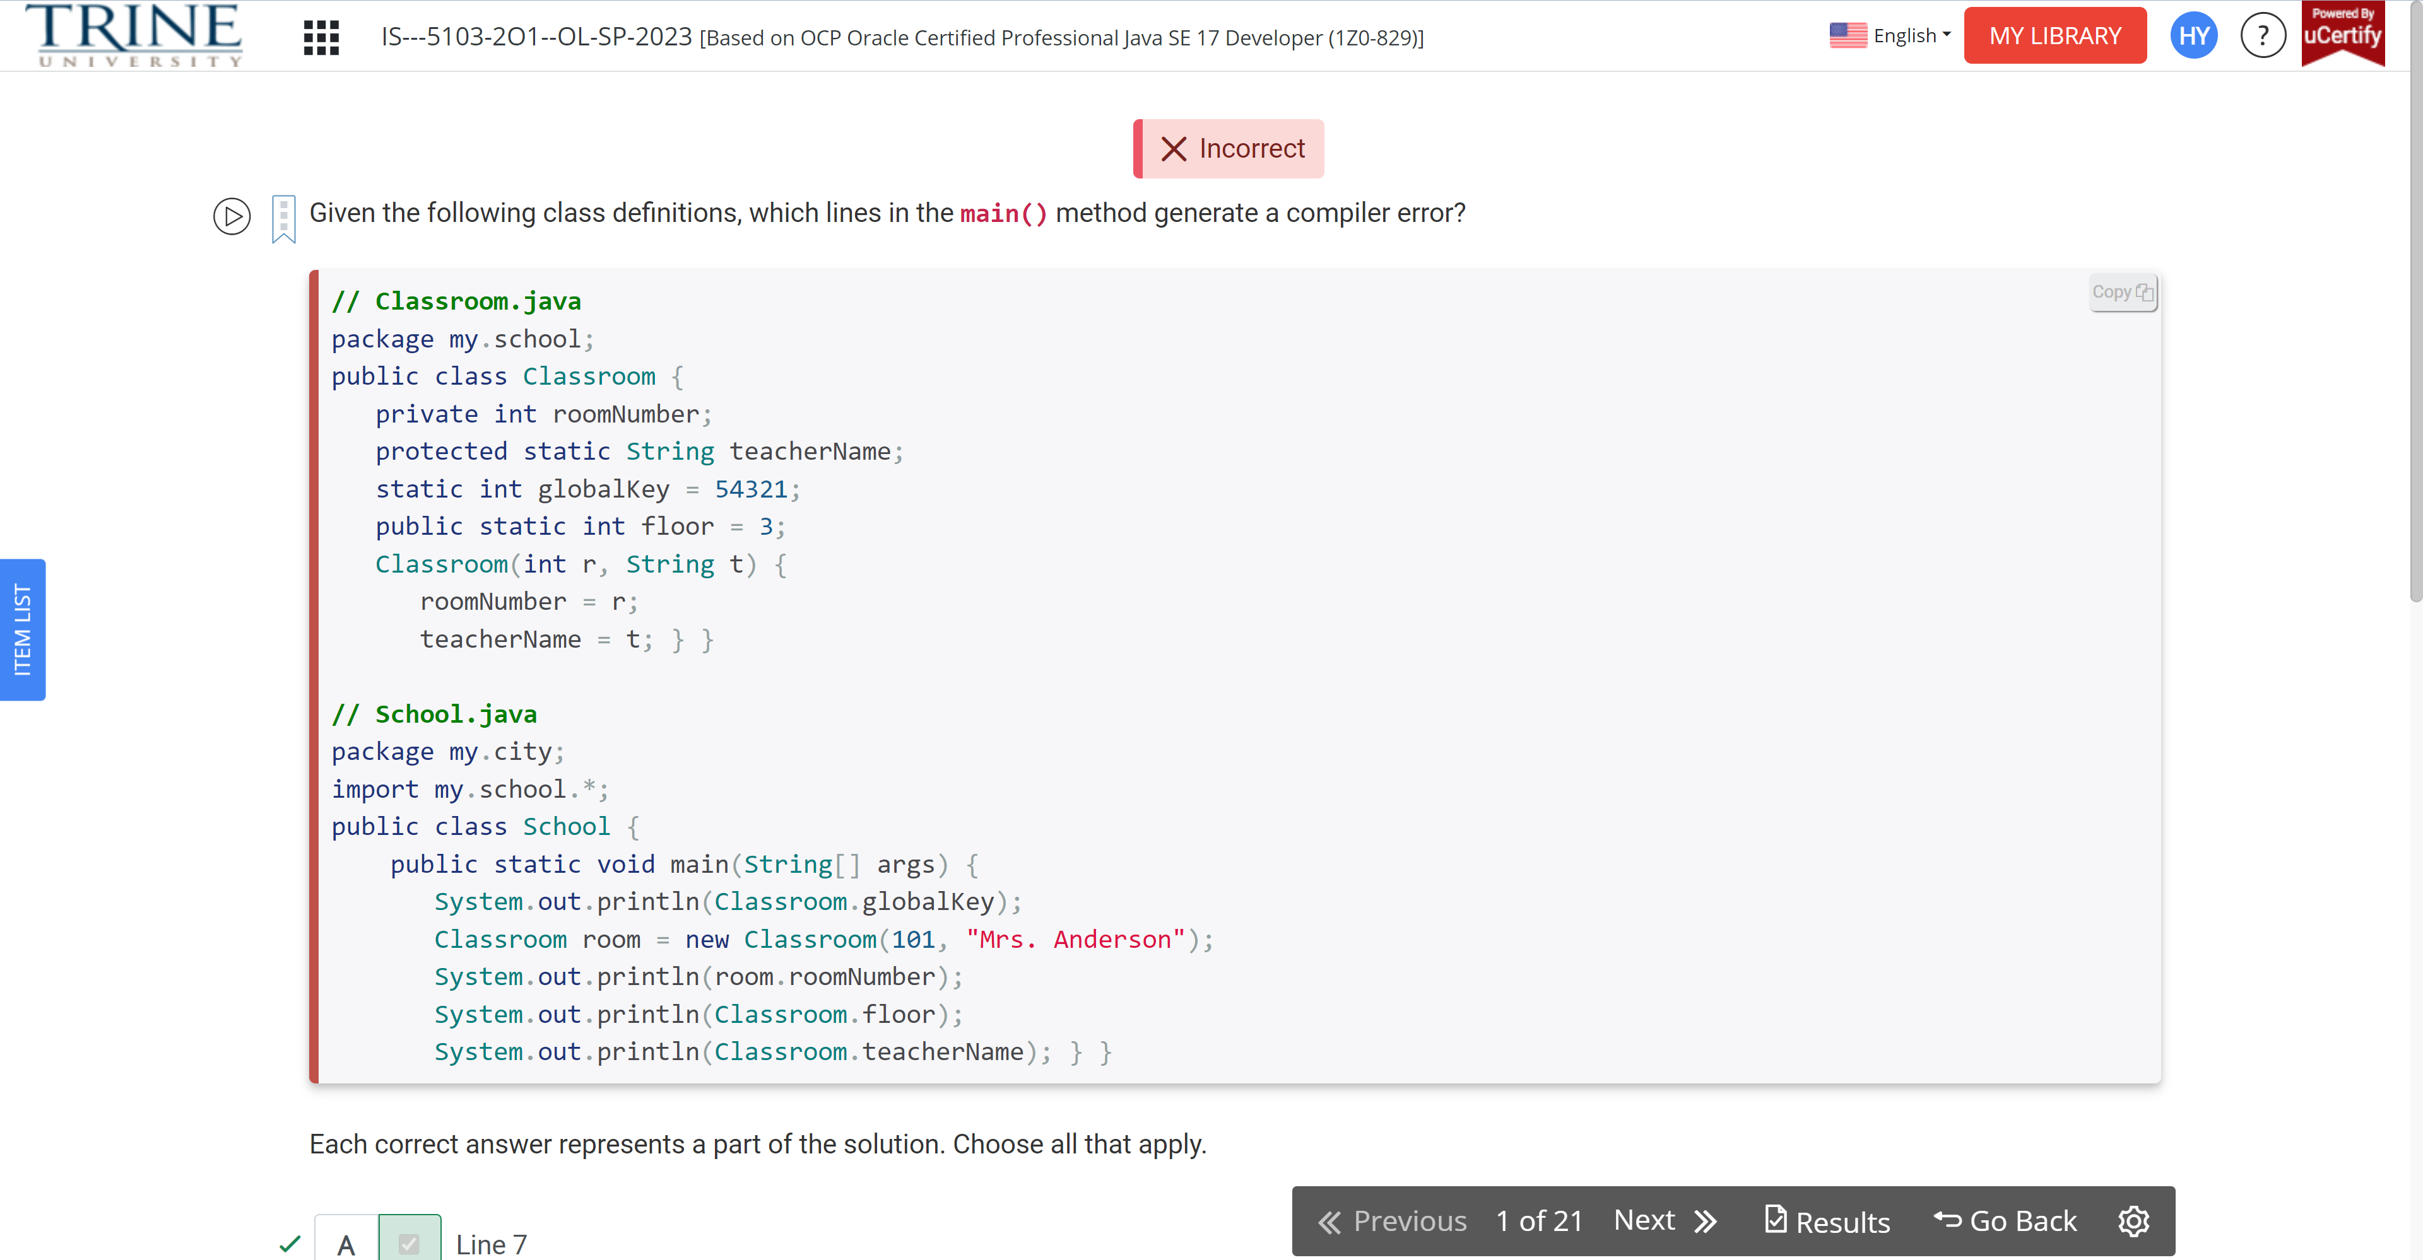

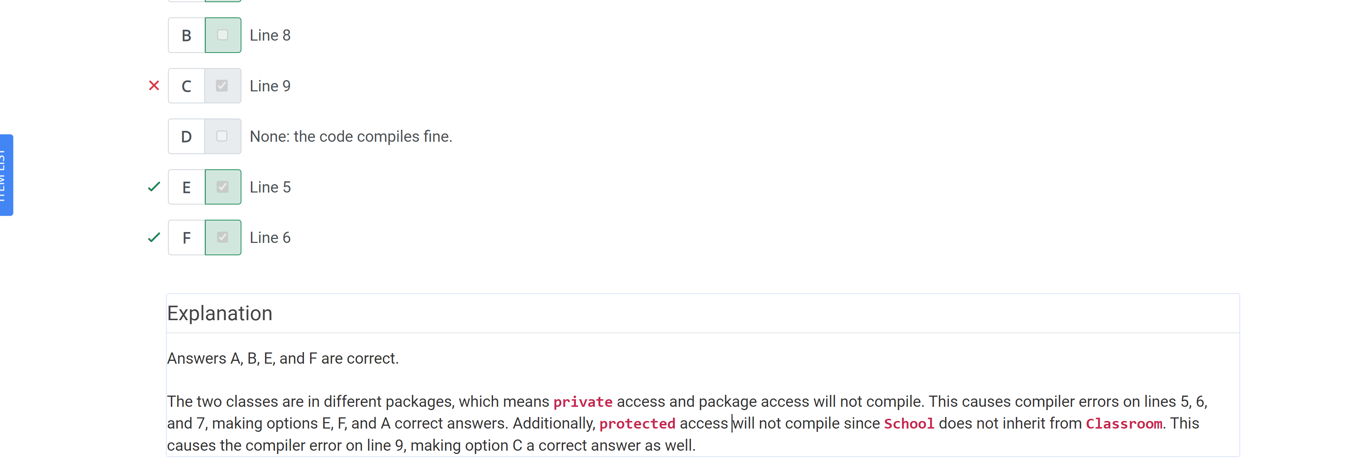

Which of the following can fill in the blank in this code to make it compile?

Public class Ant …

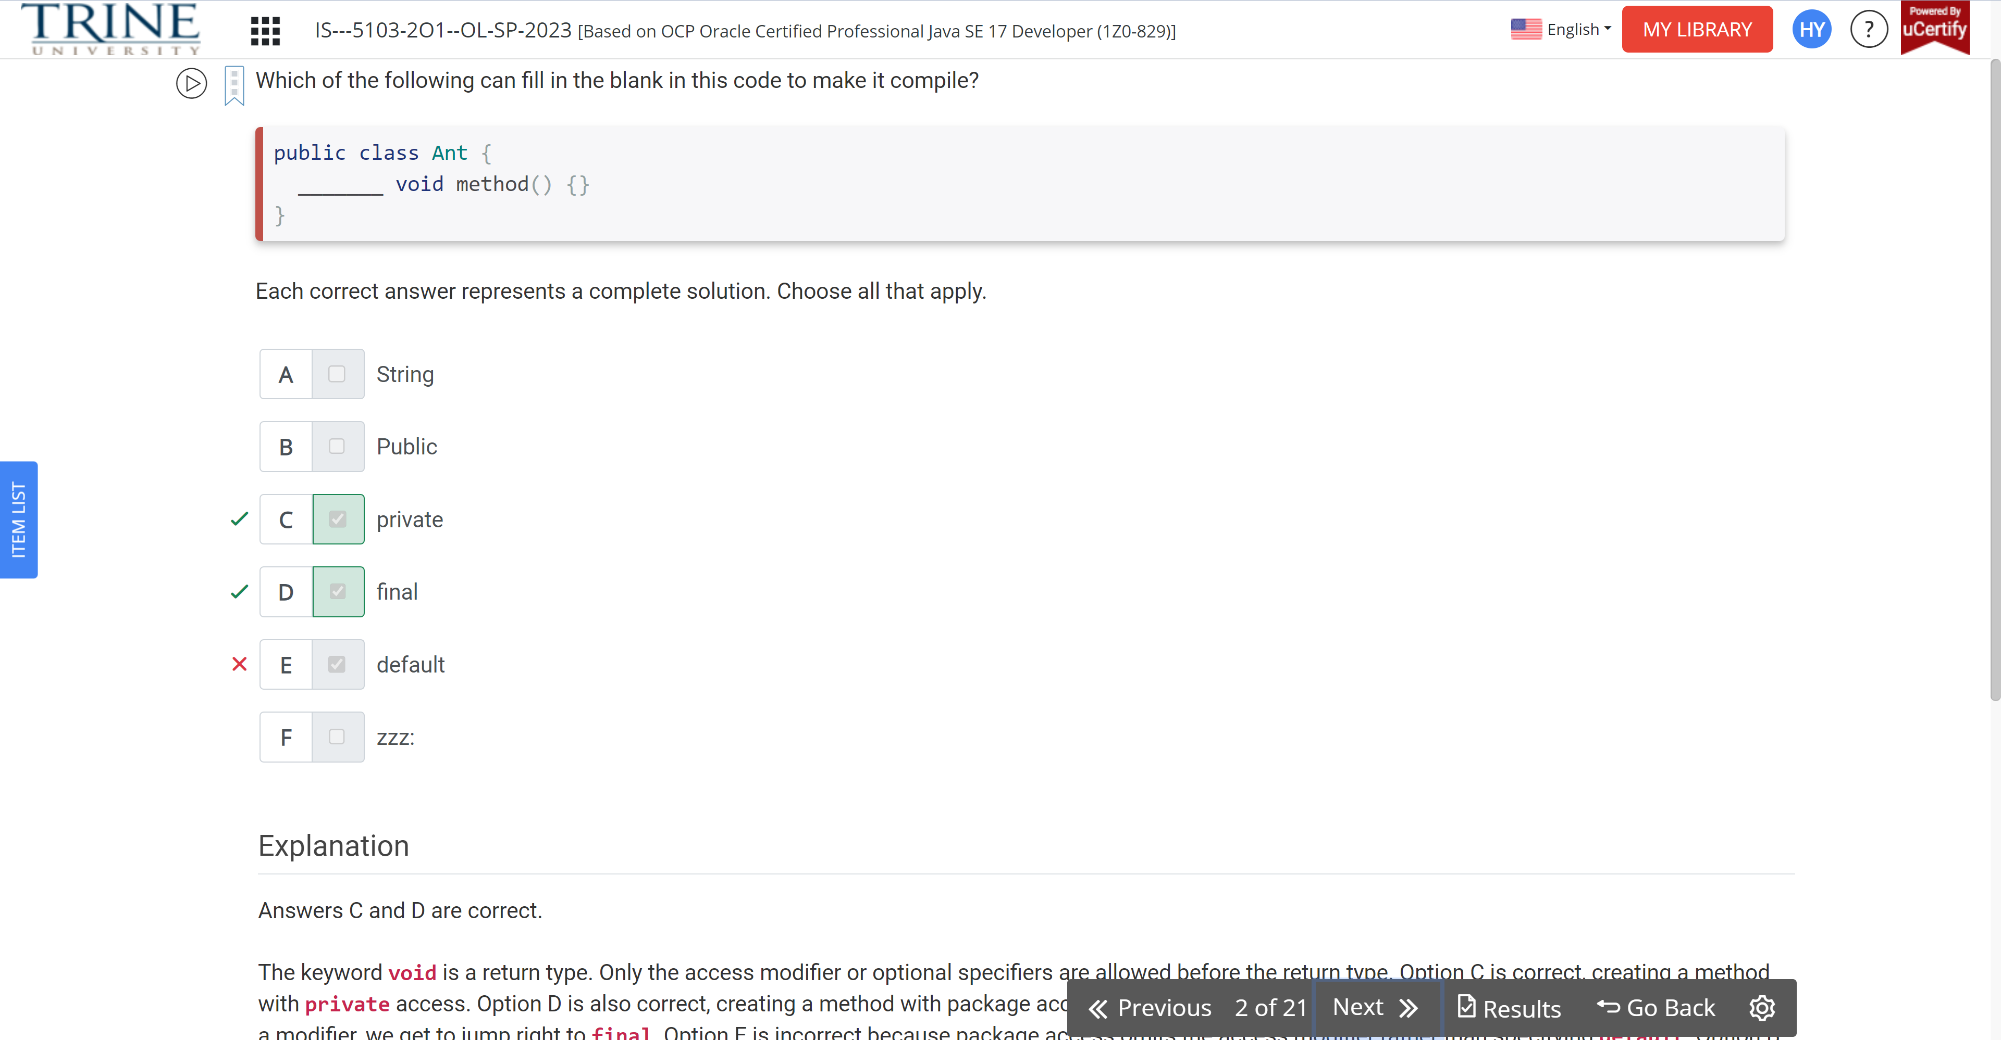

Which of the following are outputs of the following code?

Public class StringBuilders…

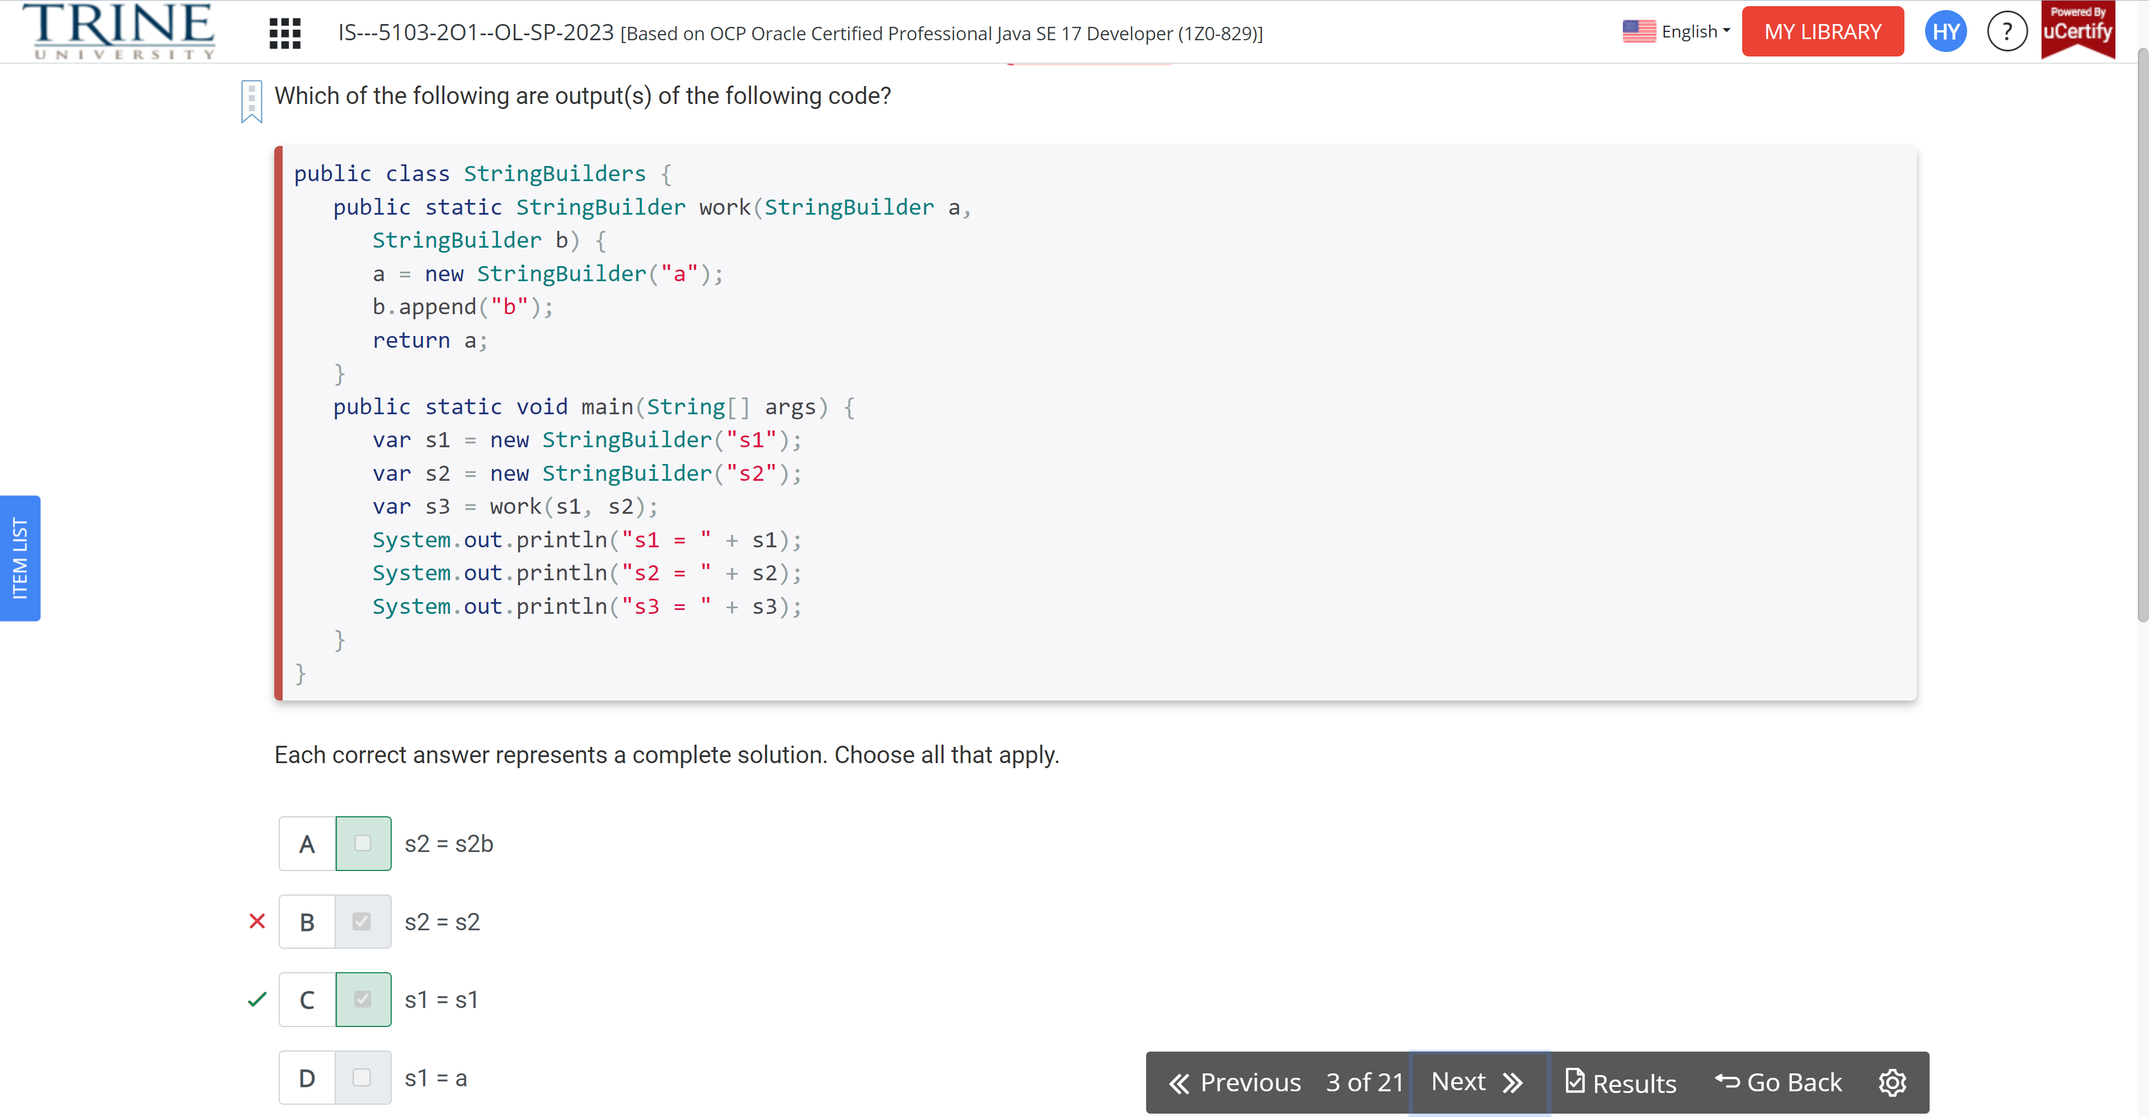

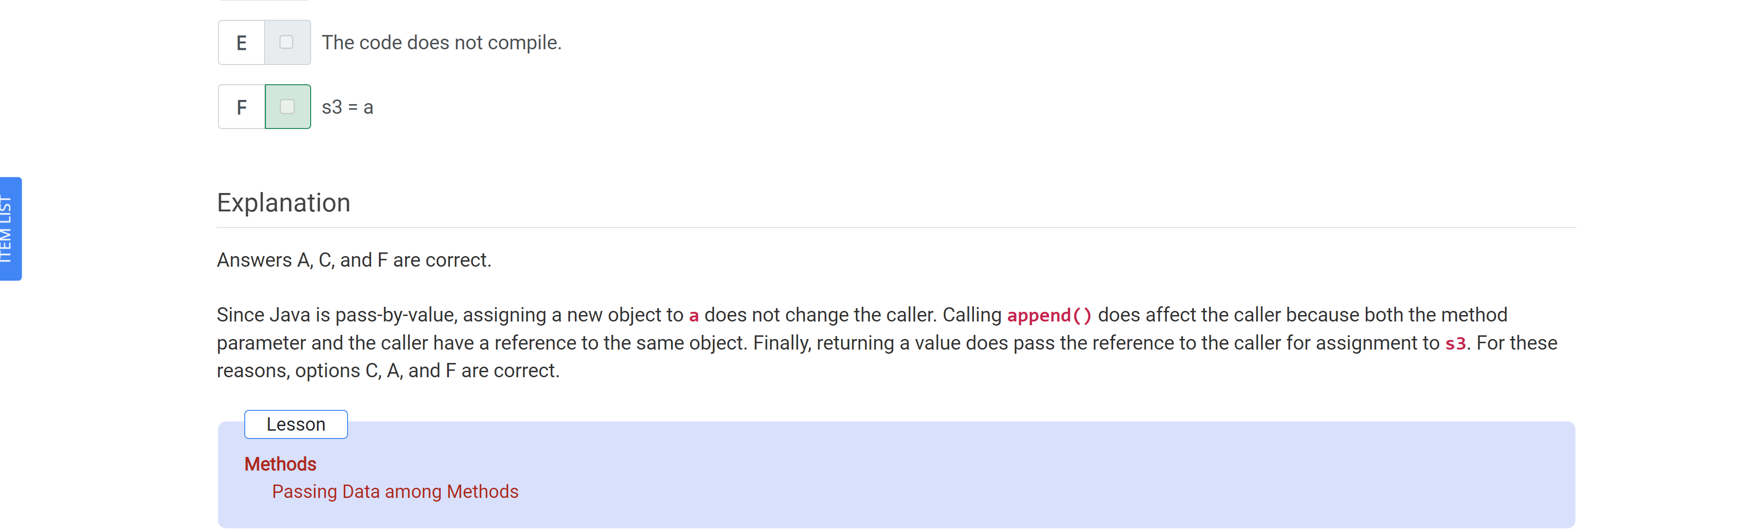

What is the result of the following statements?

Public class Test…

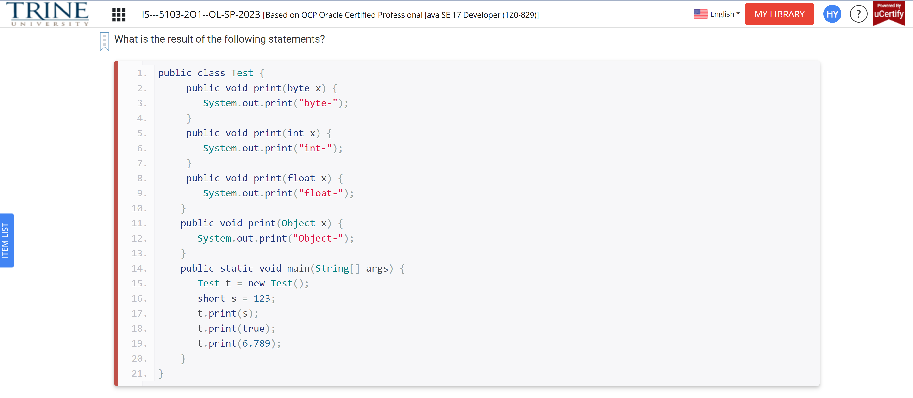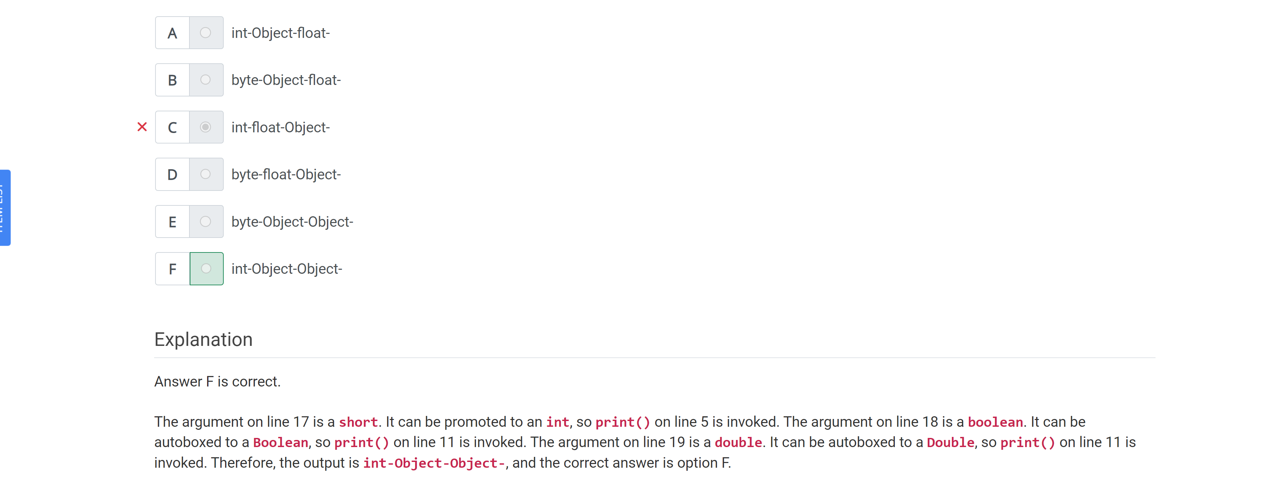

Which of the following methods compile,

Void final ice…

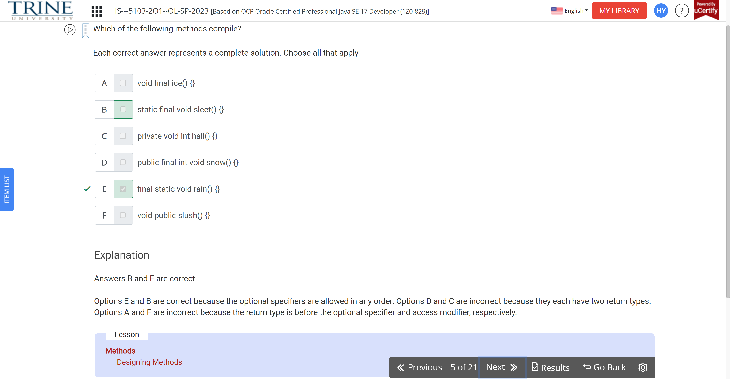

What is the output of executing the Chimp program?

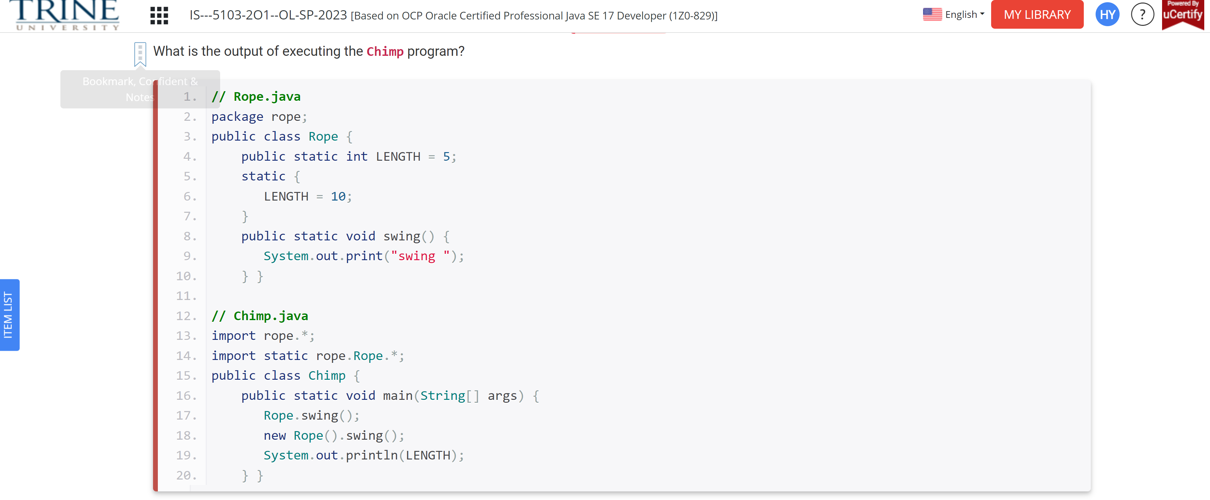

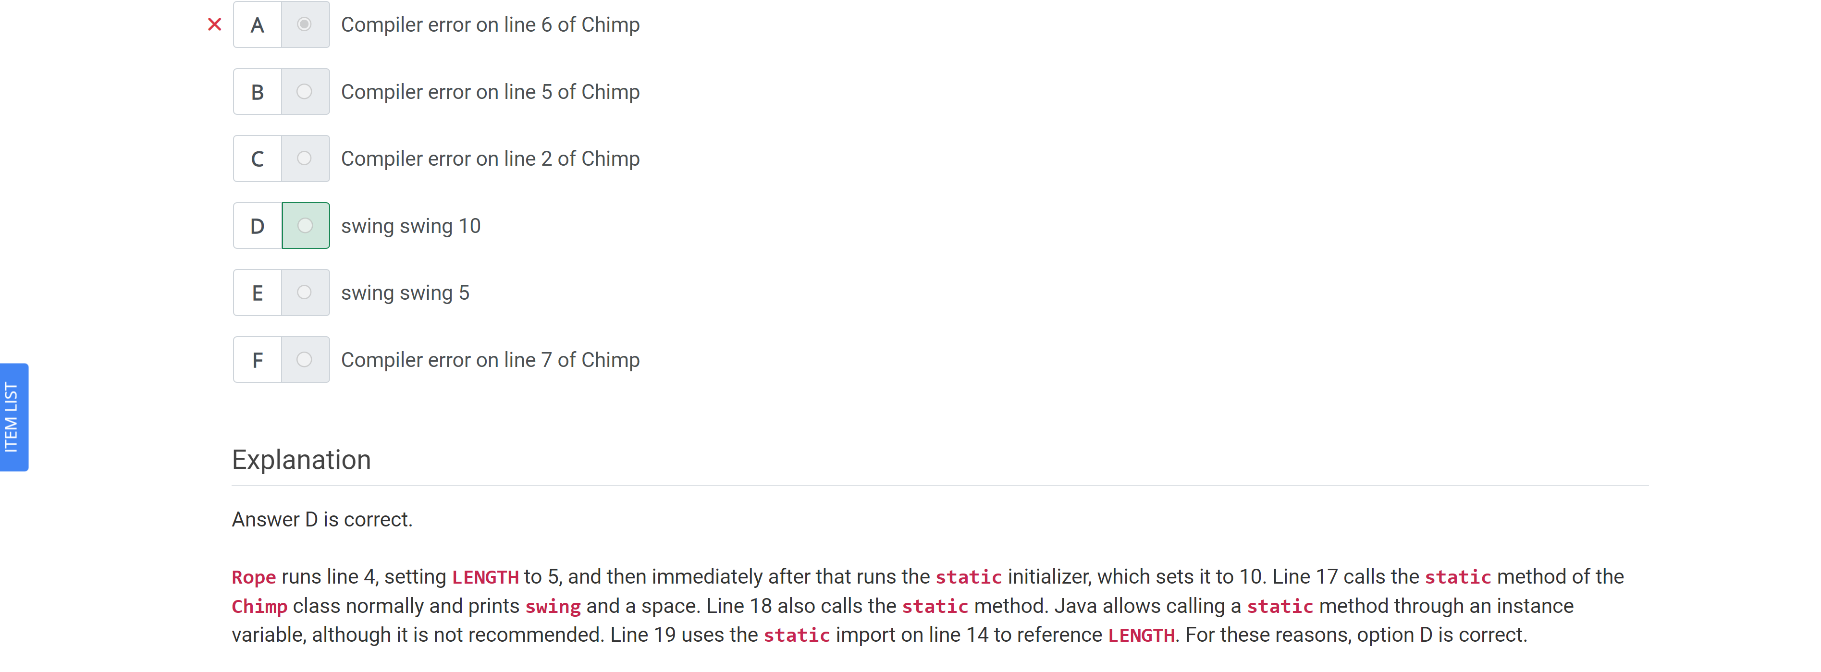

Which of the following will compile when independently inserted in the following code?

Public class Order3 …

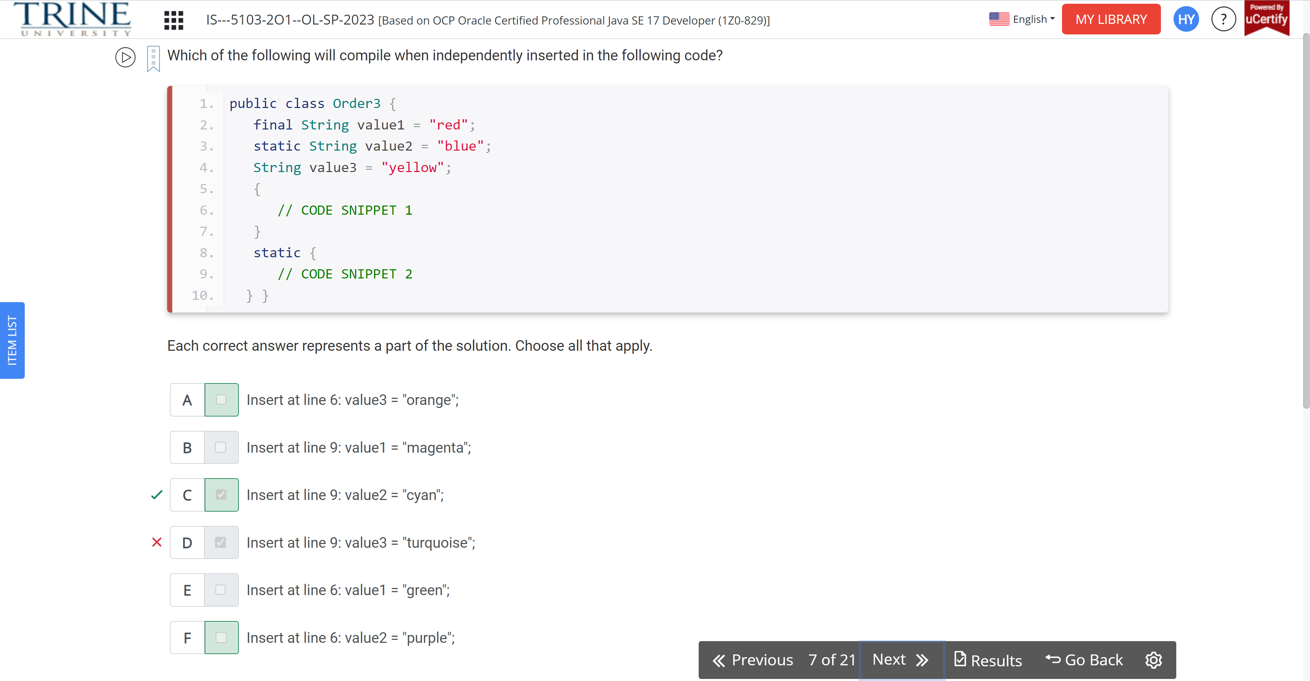

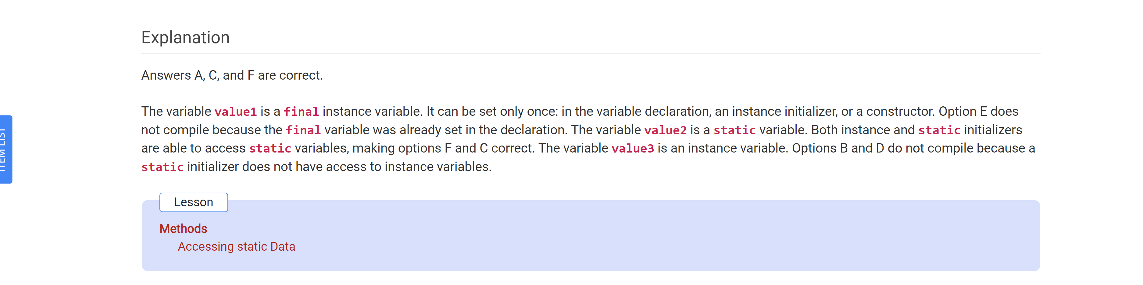

Which of the following can replace line2 to make this code compile?

Import java.util.\*;

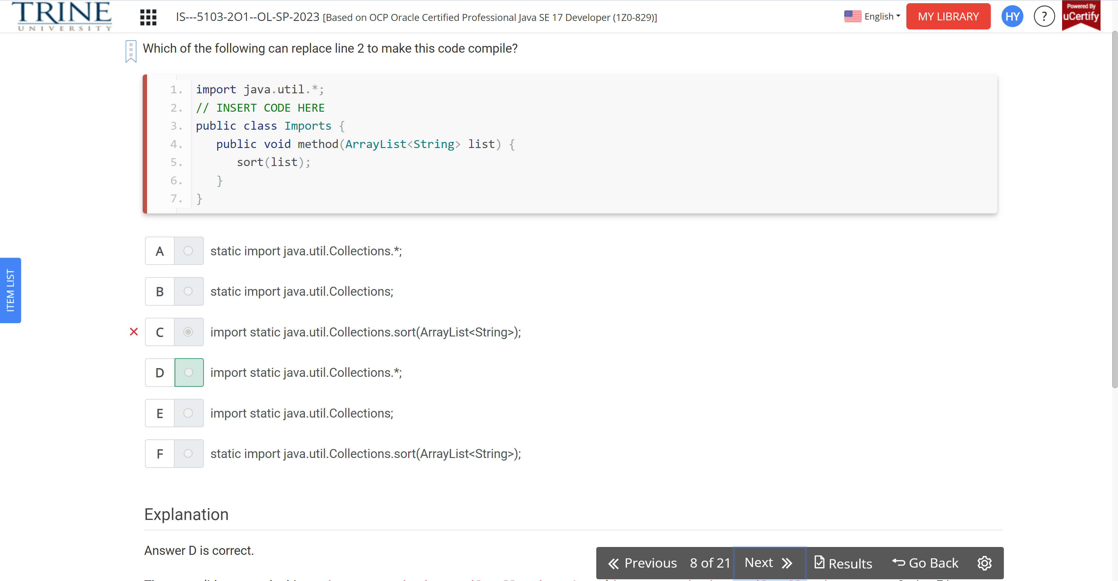

What is the output of the following code?

//RopeSwing.java

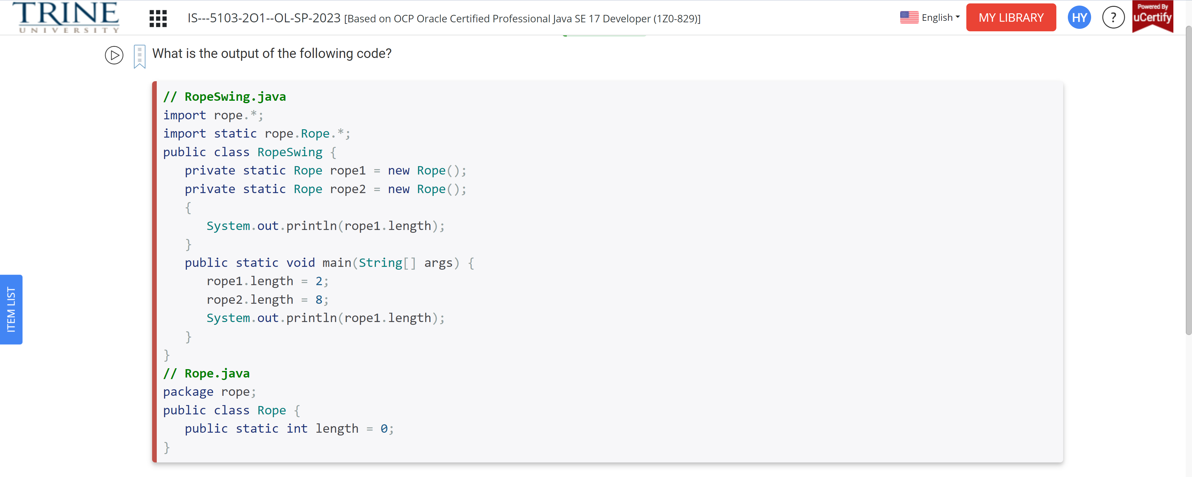

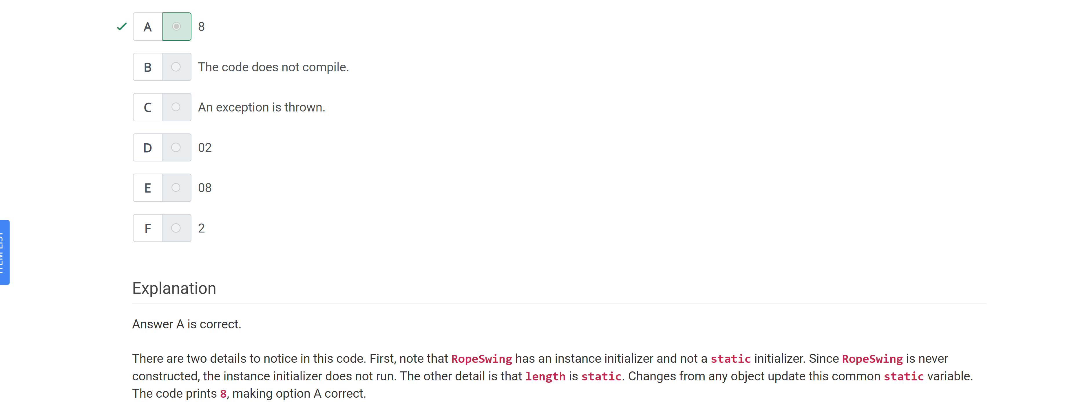

Which statements about the final modifier are correct?

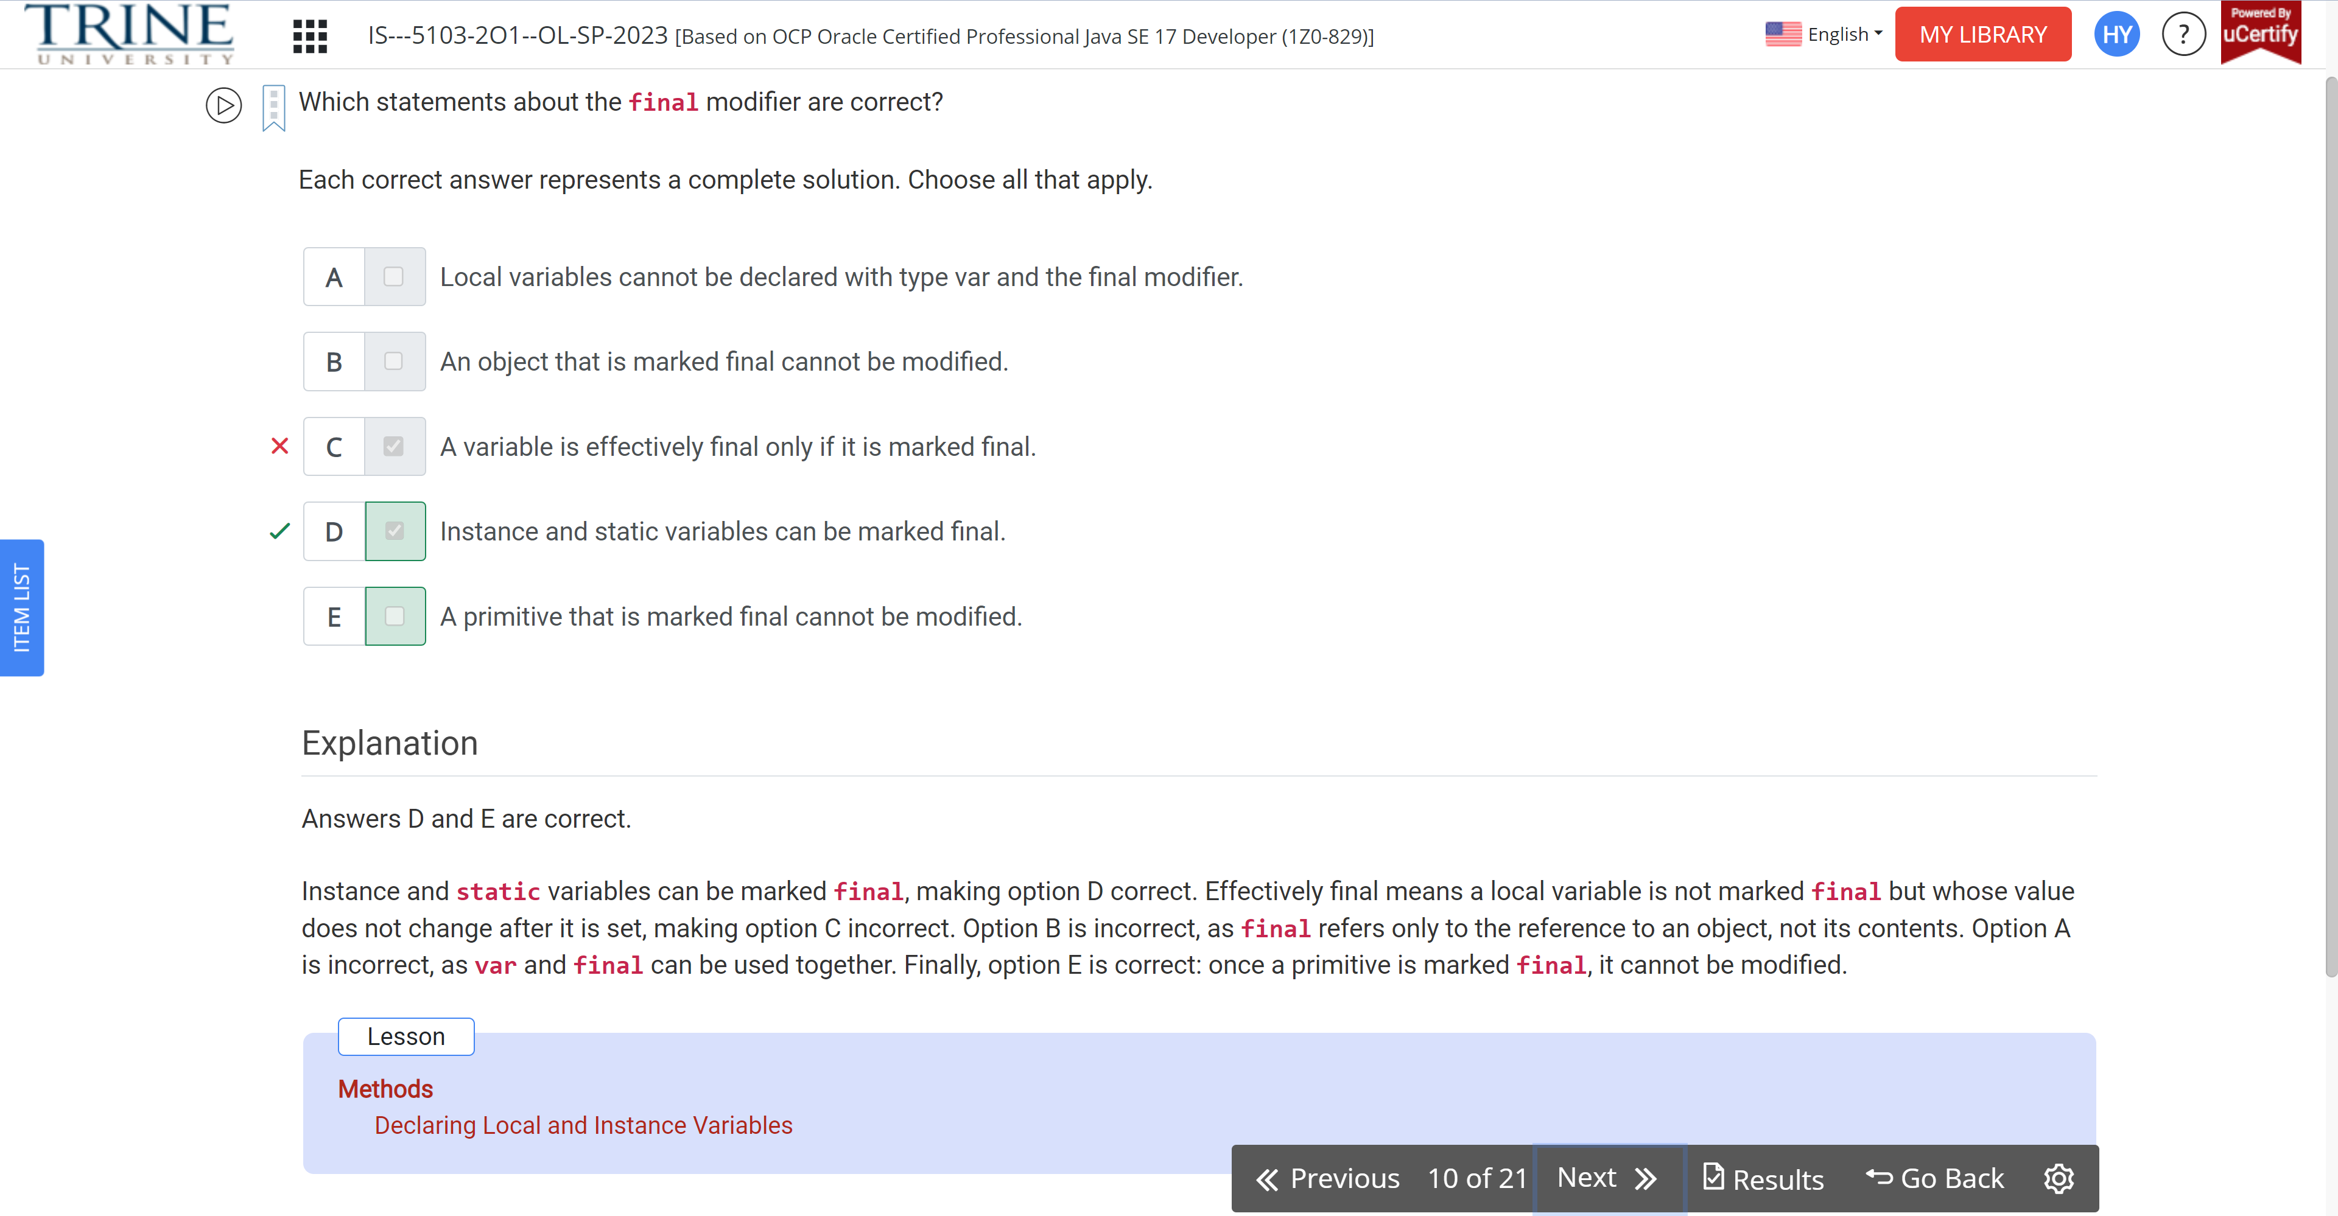

Which of the following can fill in the blank and allow the code to compile?

Final … song = 6;

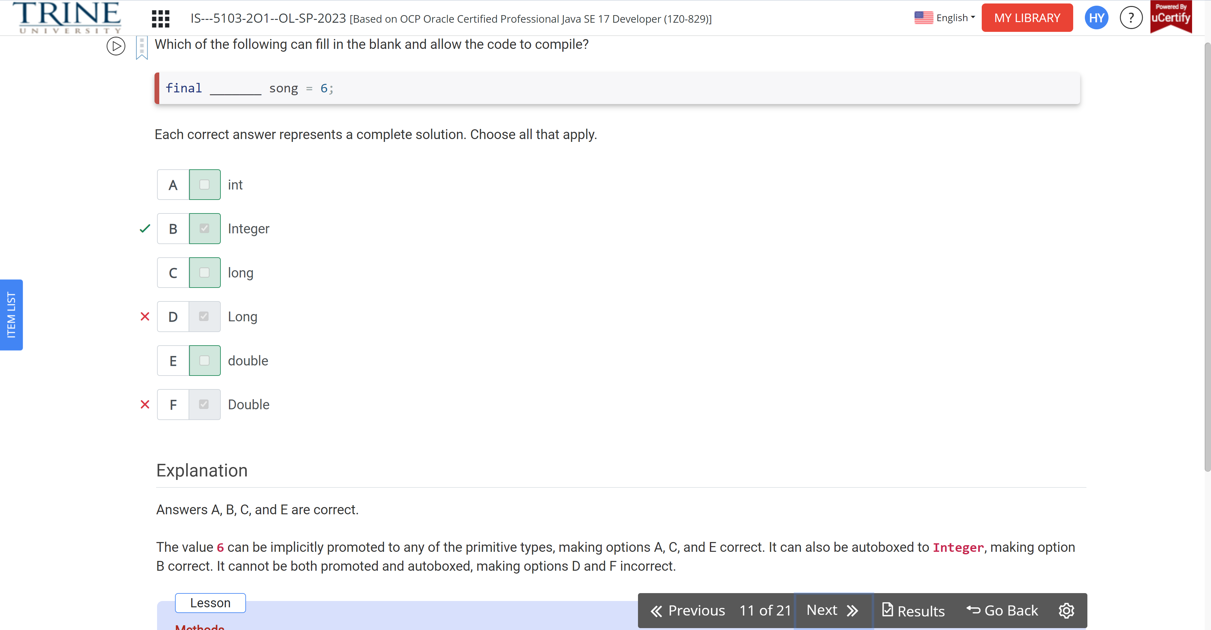

Which statements are true of the following code?

Public class Rope …

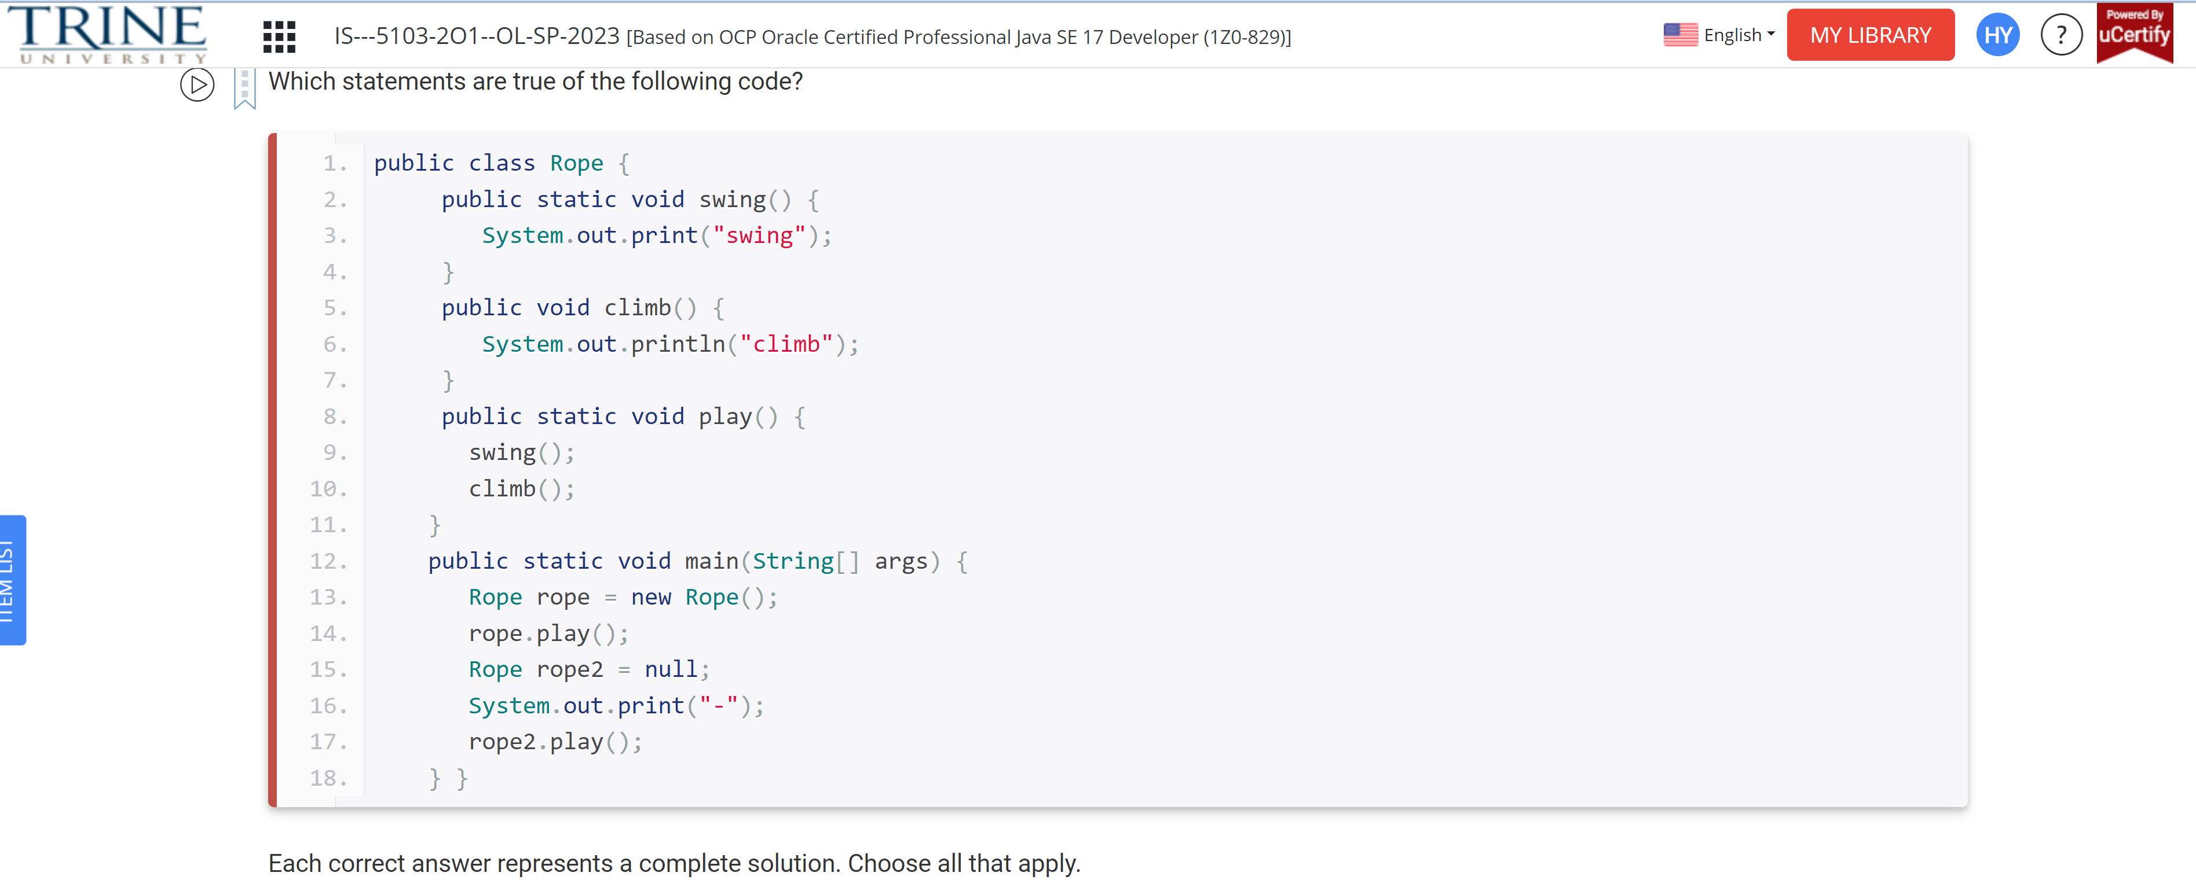

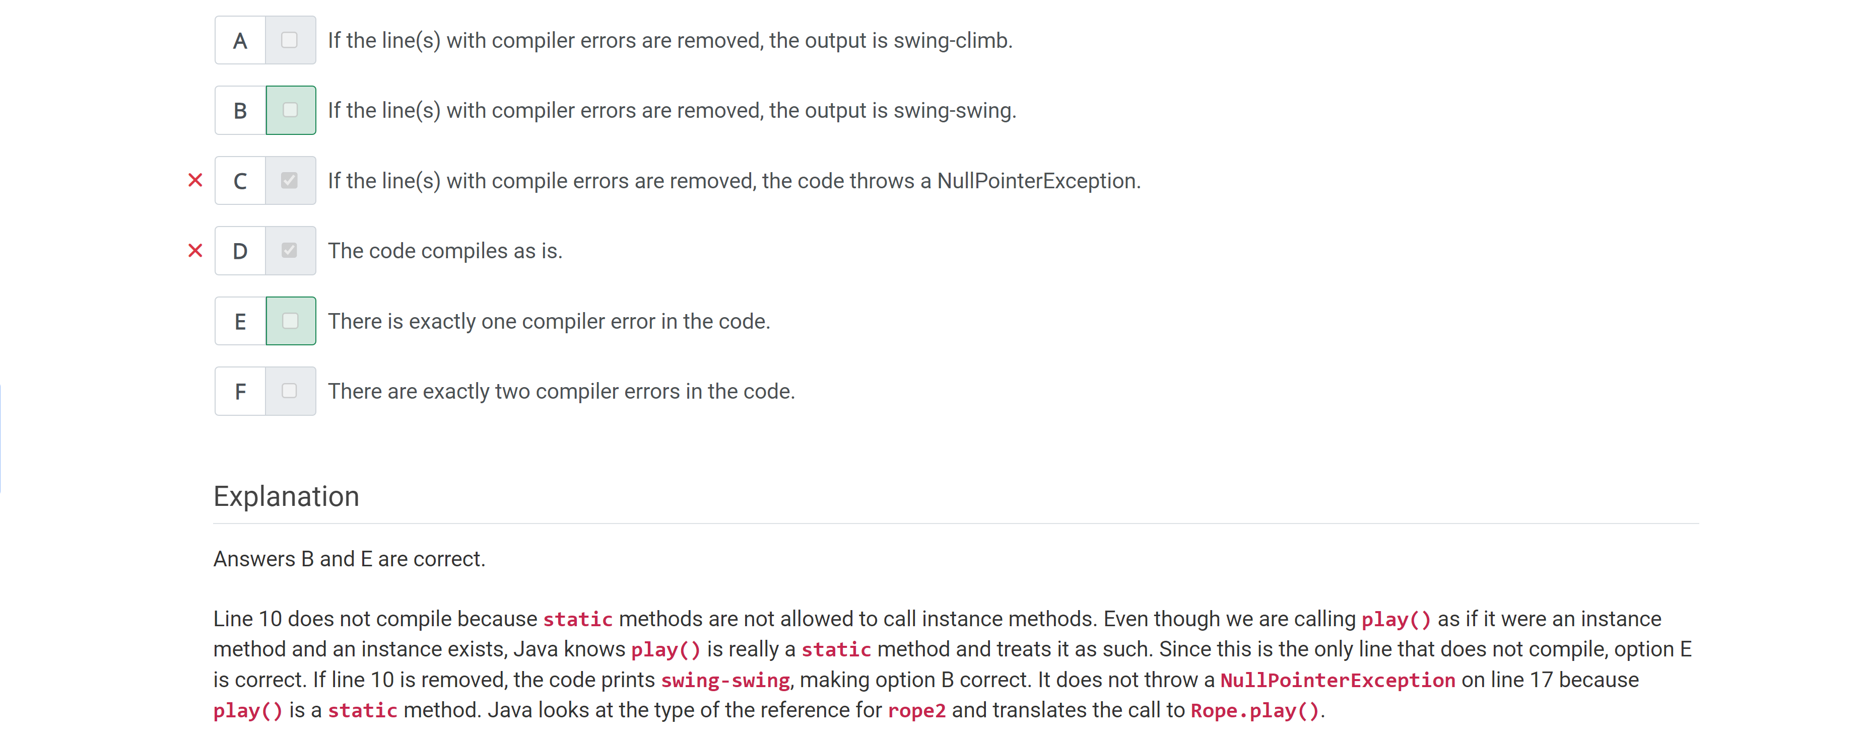

Which of the following statements is correct?

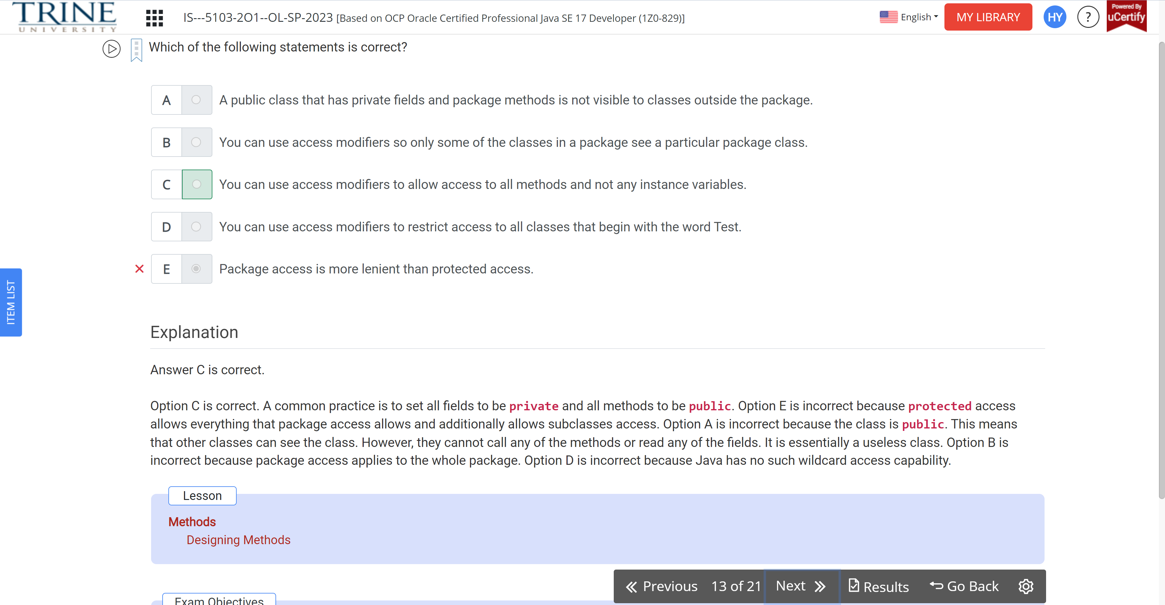

What is the result of the following program?

Public class Squares…

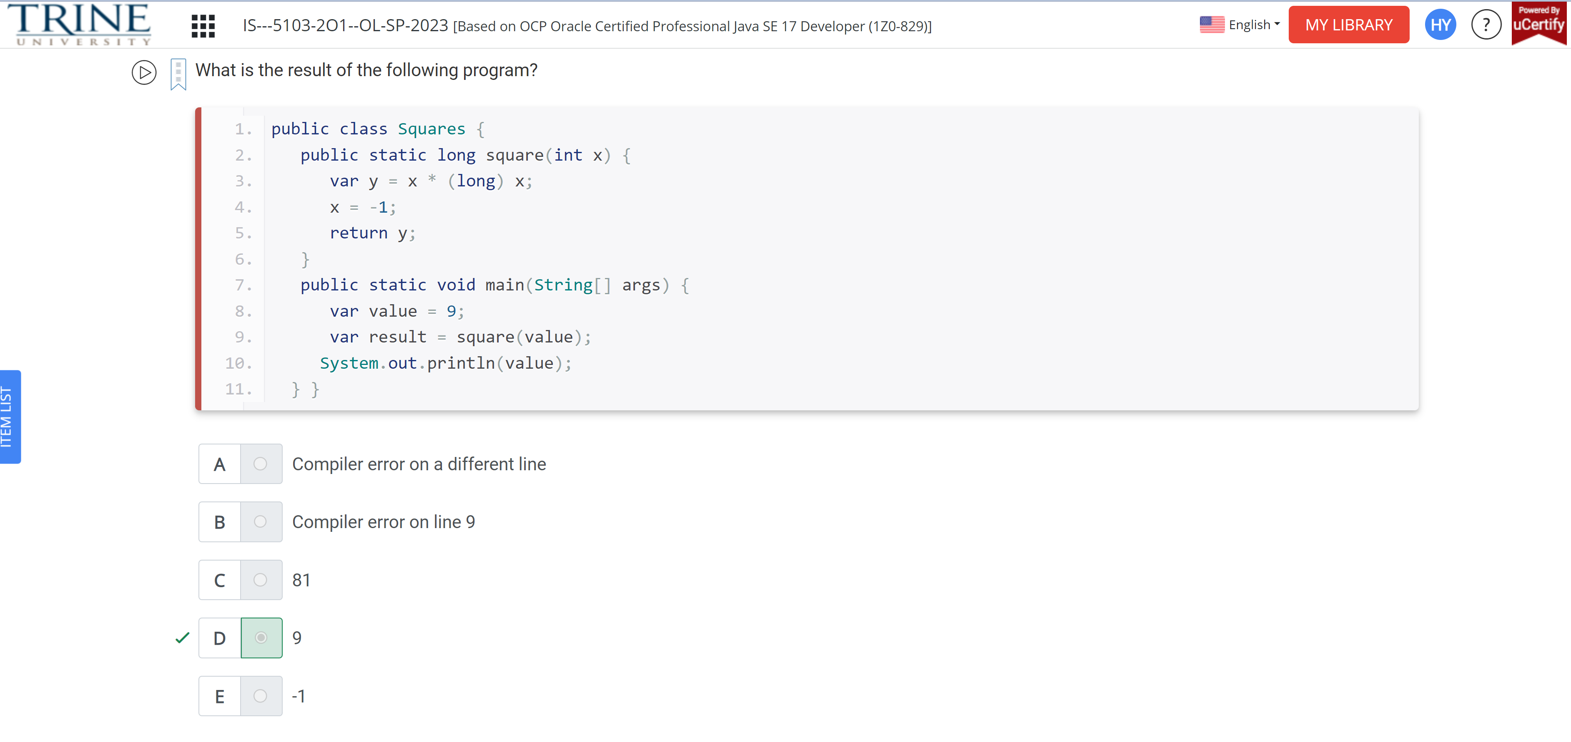

Which of the following are true about the following code?

Public class Run …

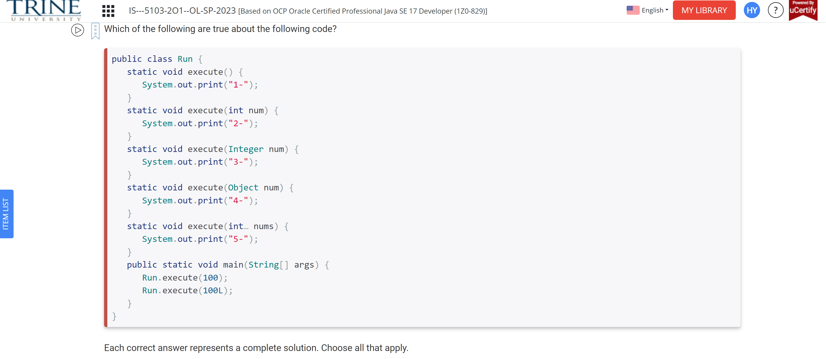

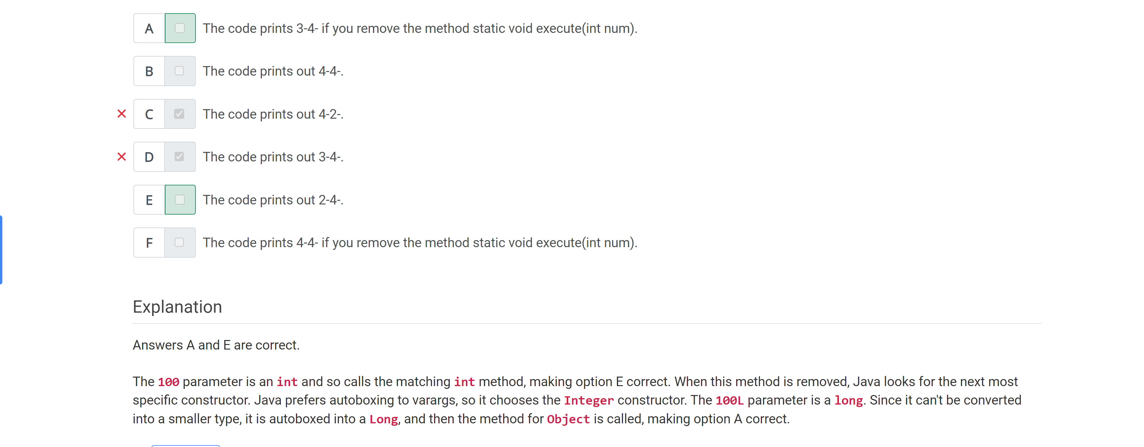

How many lines in the following code have compiler errors?

Public class RopeSwing…

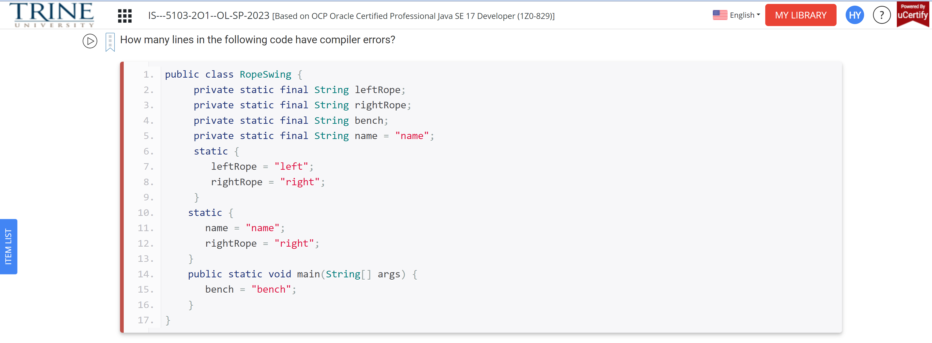

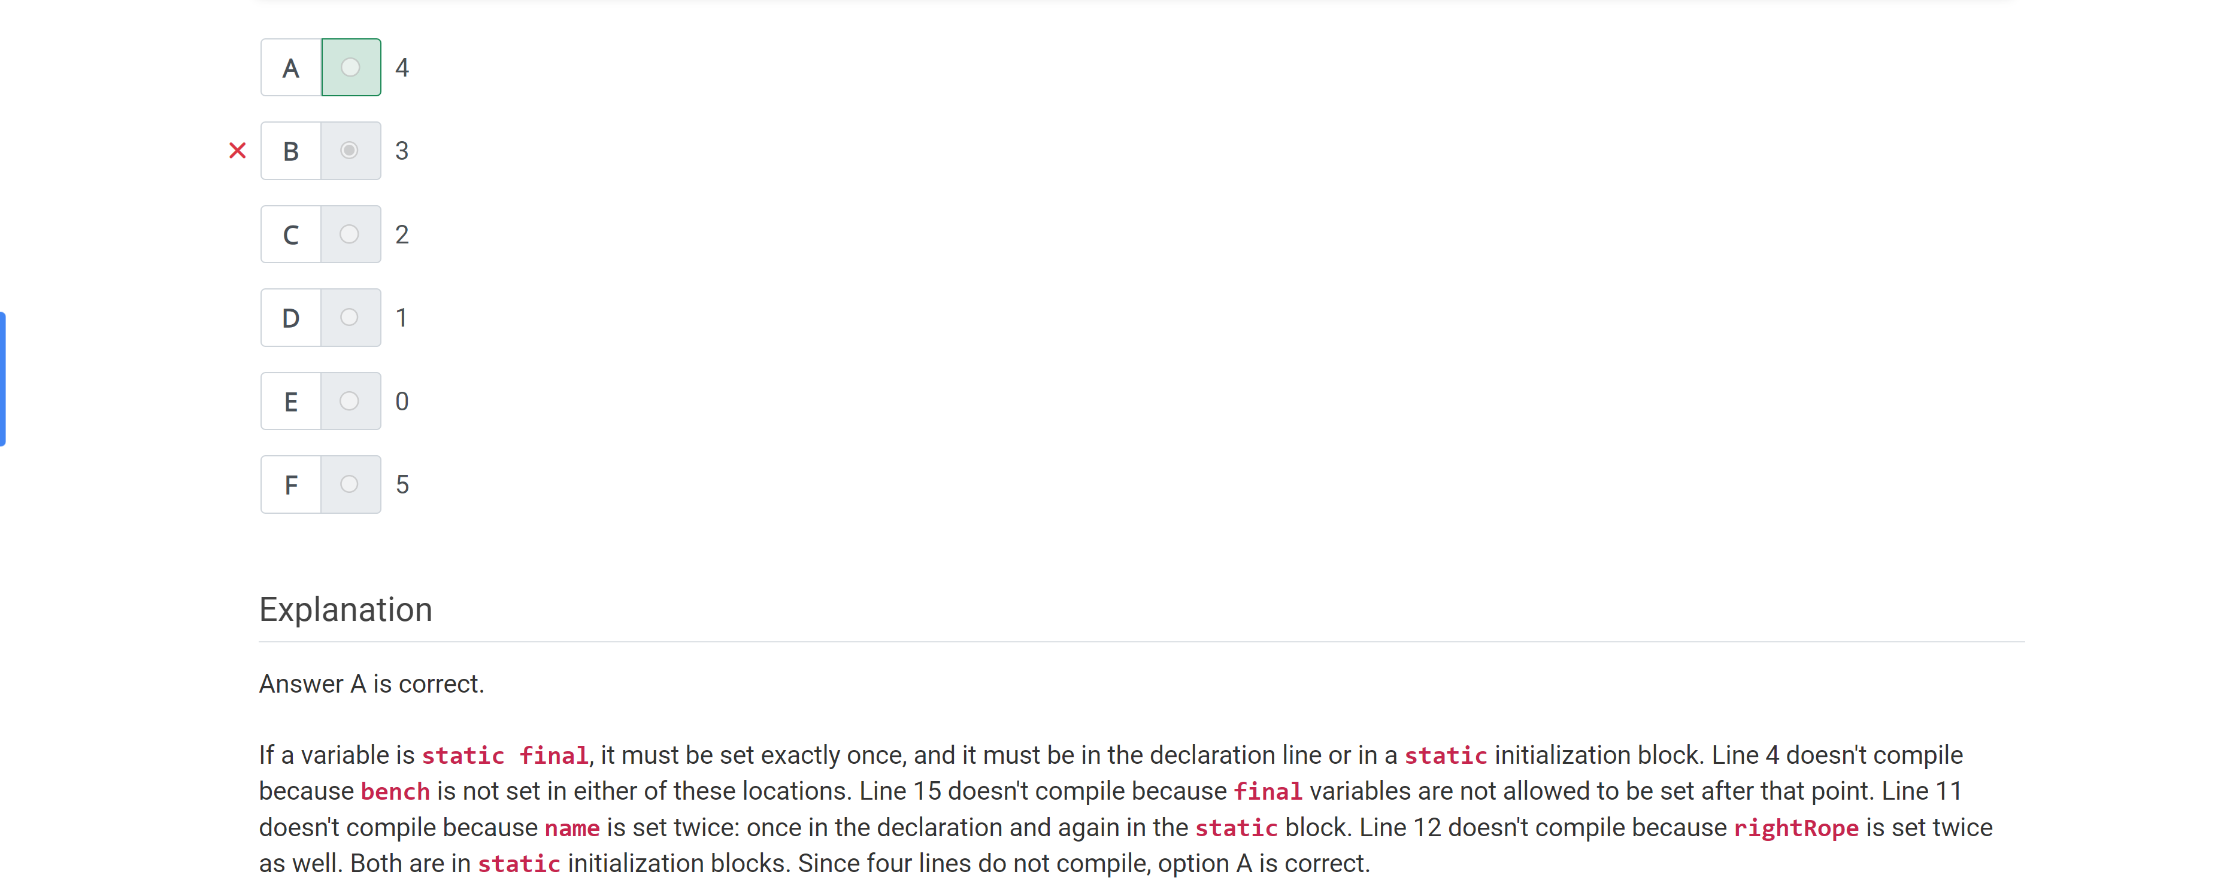

Which of the following methods compile..

Public void march() {}

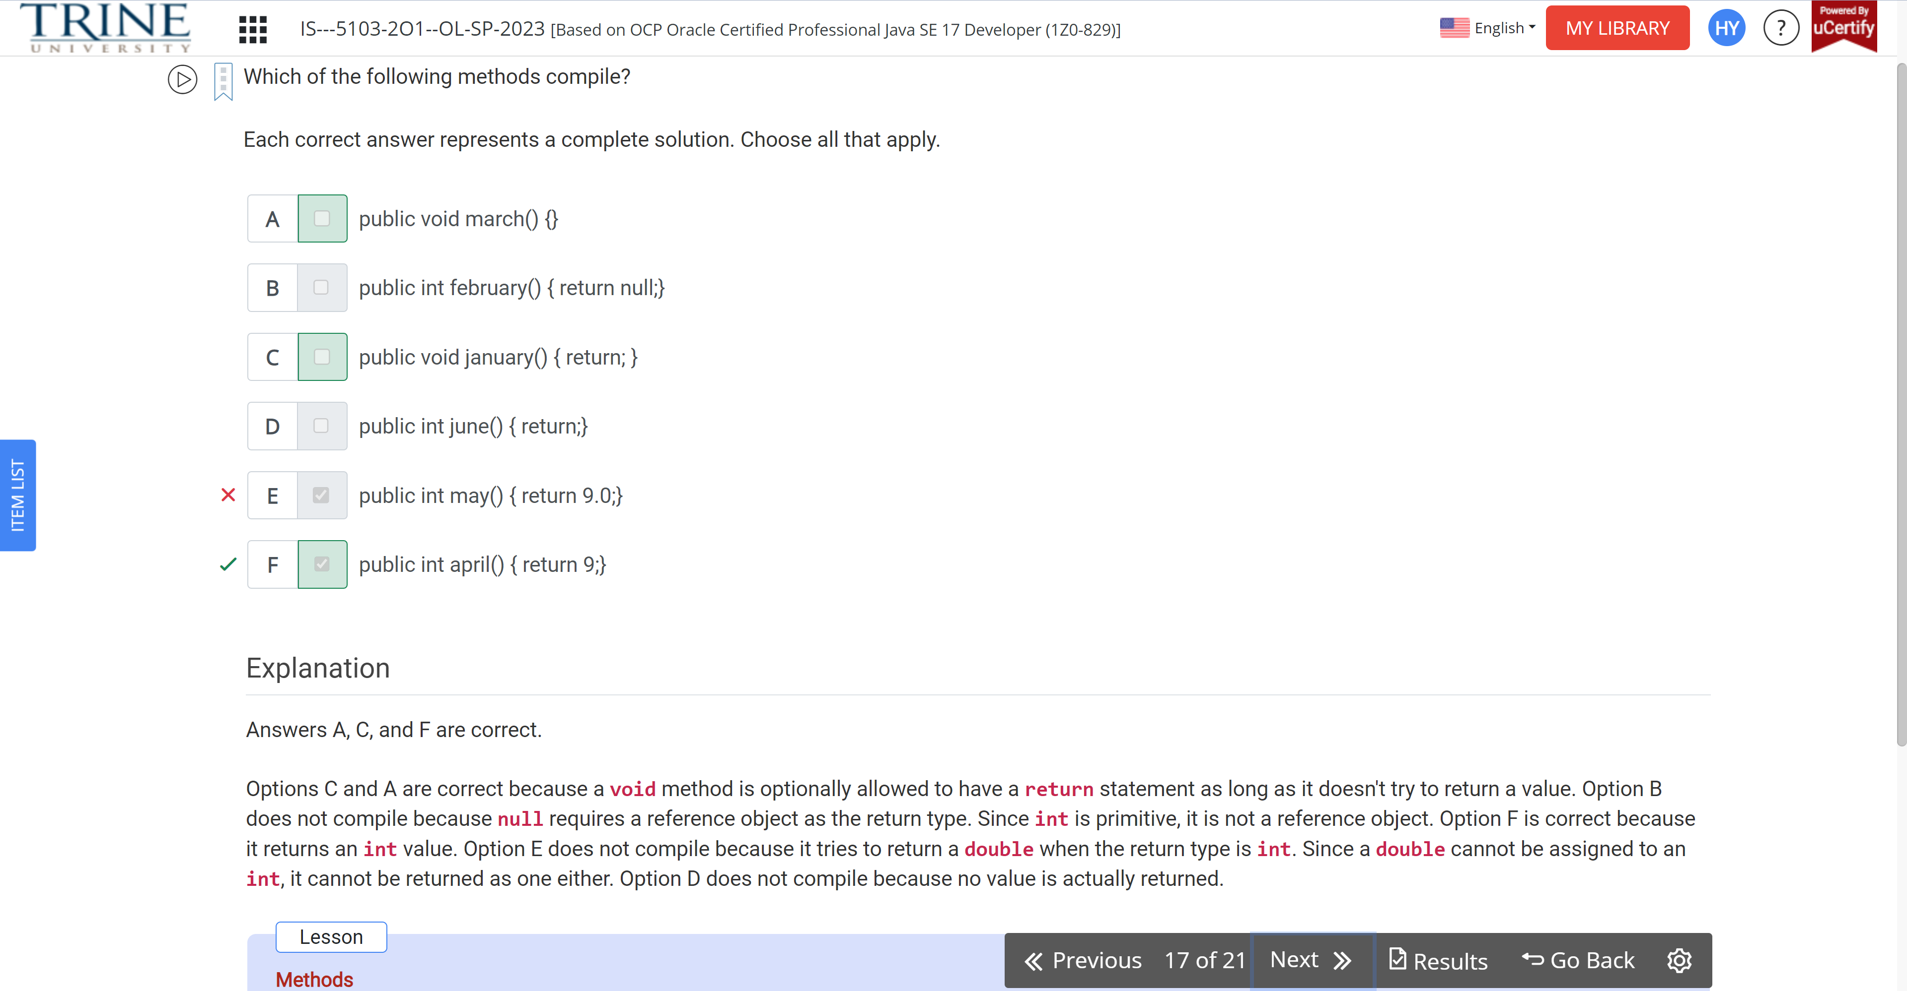

Which method signatures are valid overloads of the following method signature?

Public void moo …

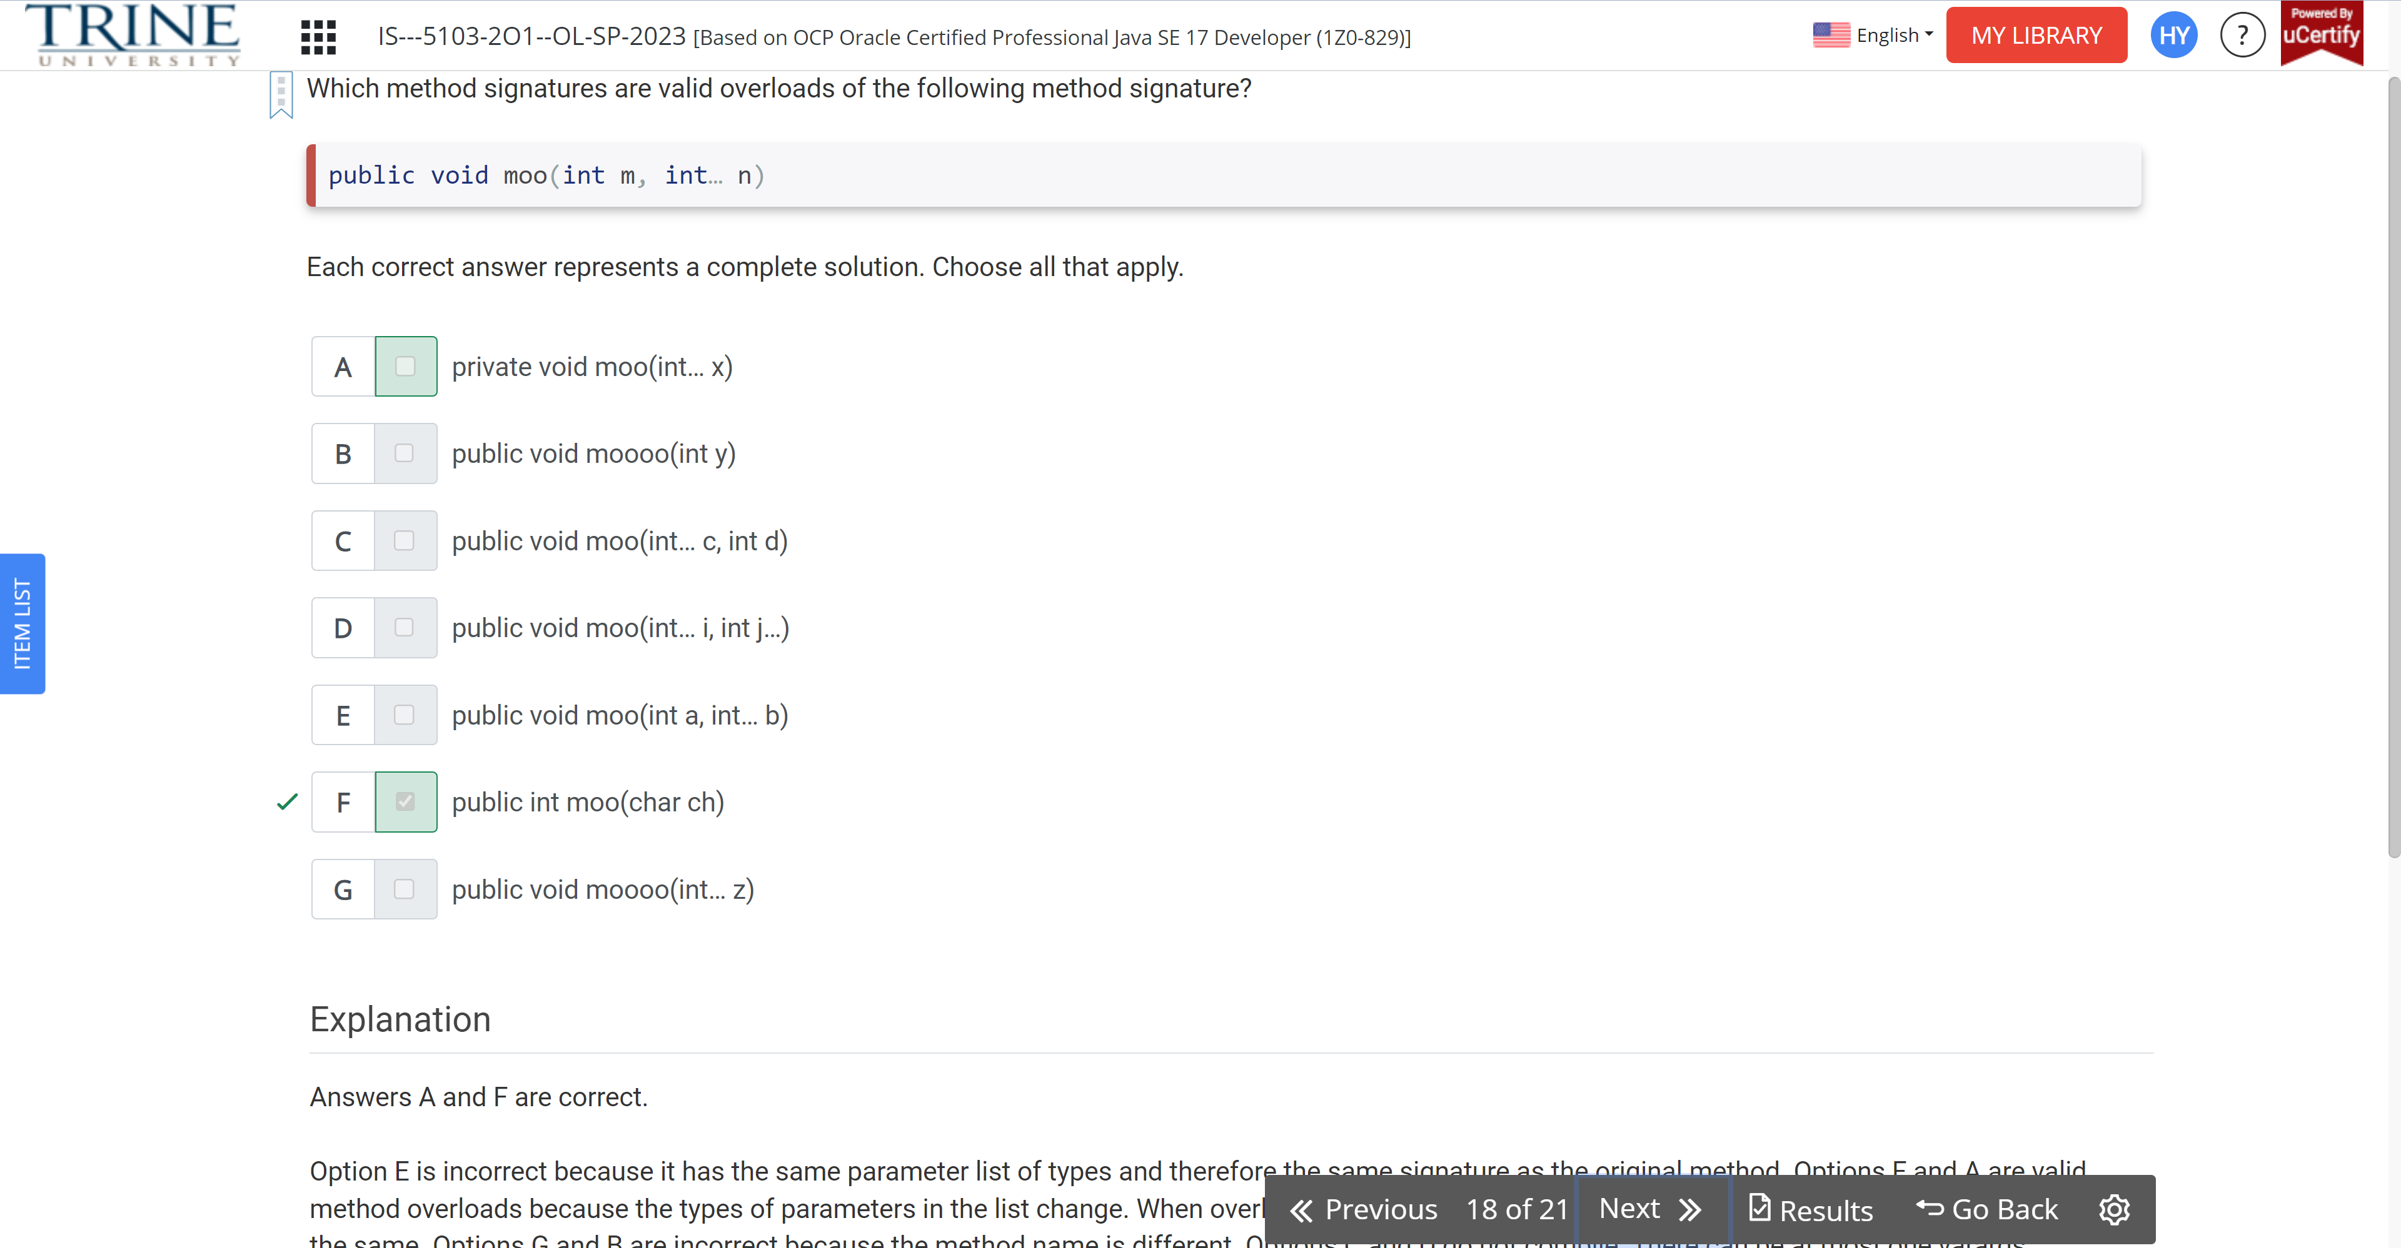

Which of the following methods compile?

Public void cello…

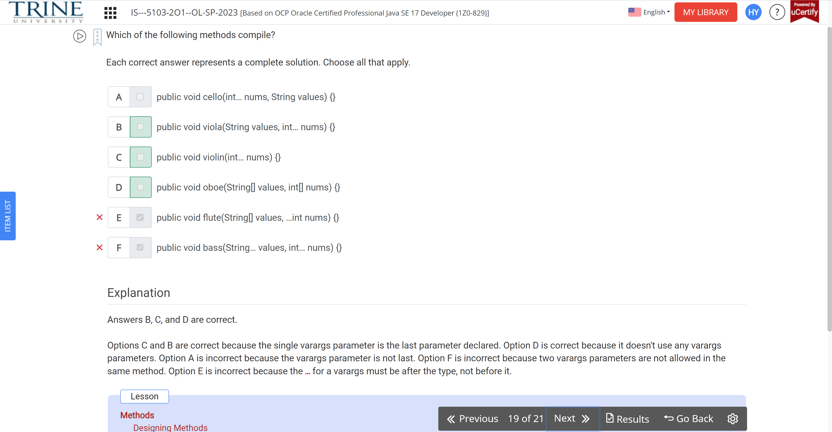

How many variables in the following method are effectively final?

Public void feed() …

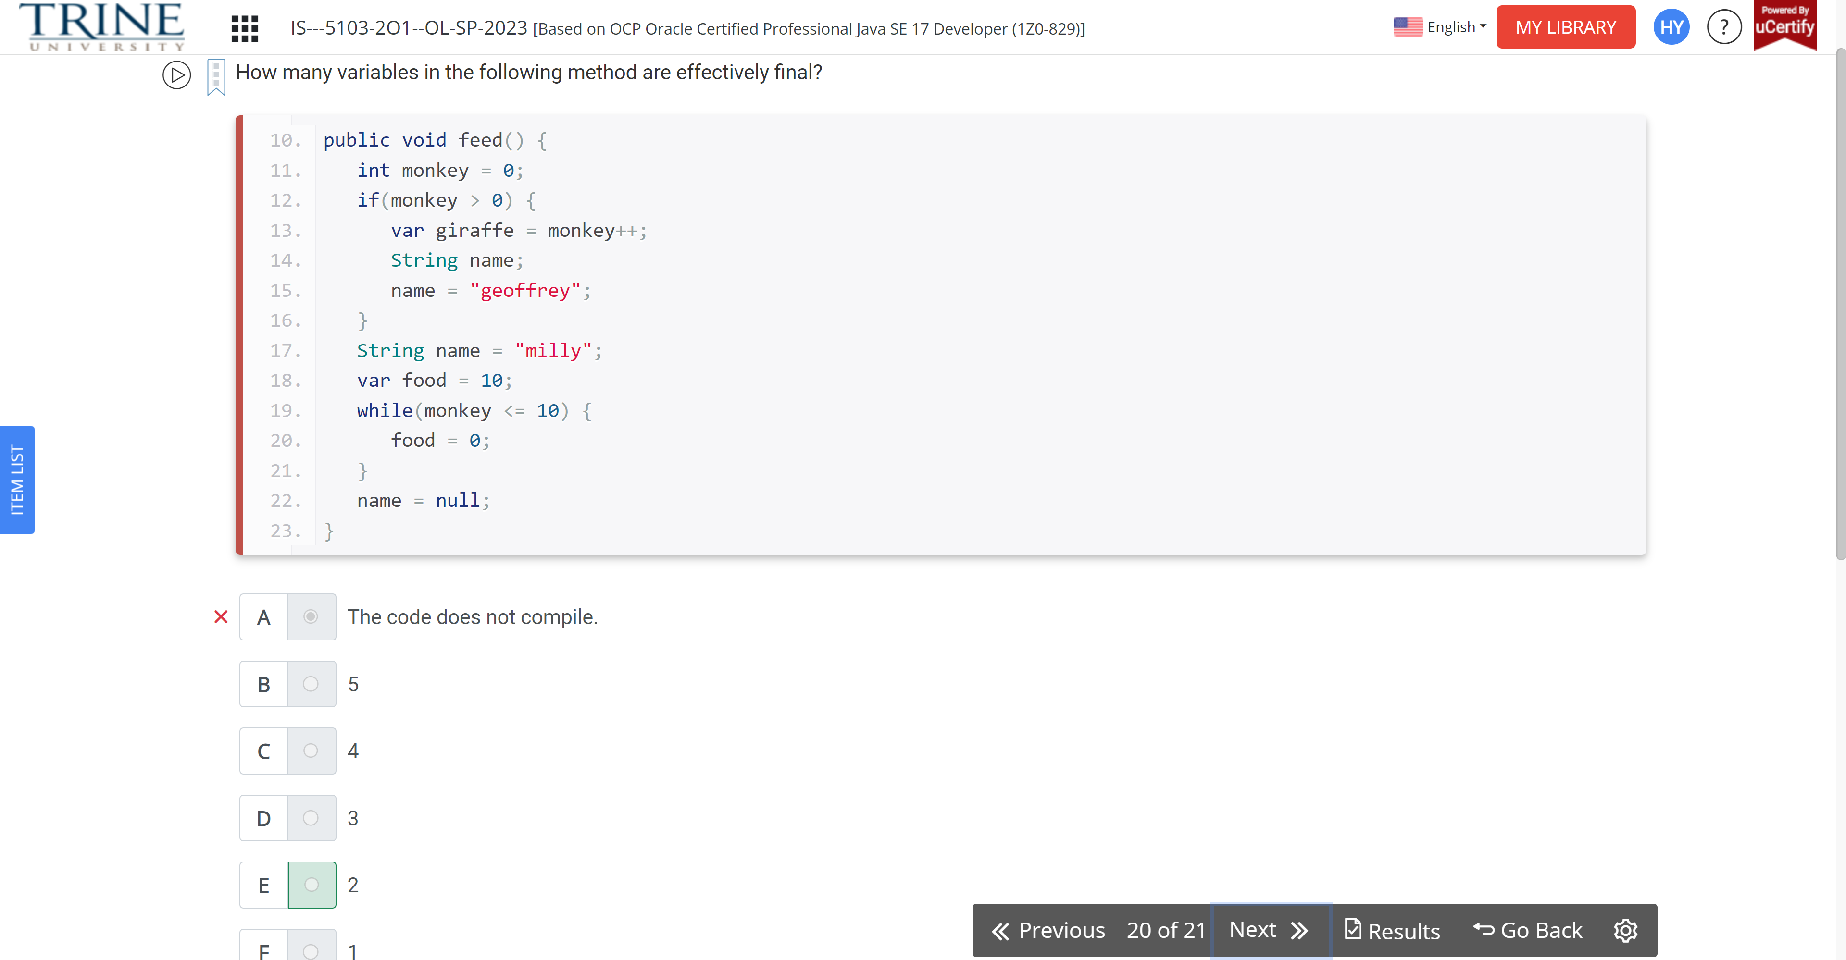

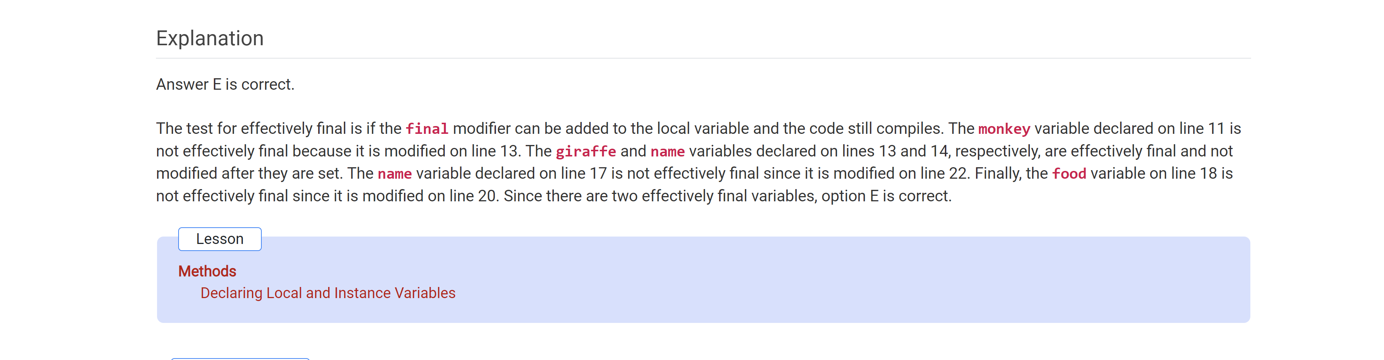

Given the following method, which of the method calls returns 2?

Public int juggle…

